主题：房屋设计

题型：流程图

The diagrams below show some principles of house design for cool and for warm climates.

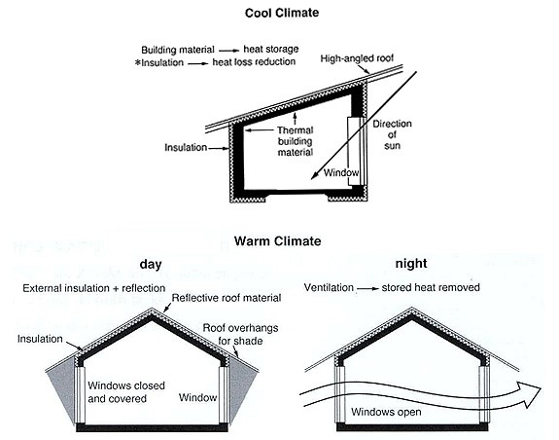

满分范文：

The diagrams show how house designs differ according to climate.

The most noticeable difference between houses designed for cool and warm climates is in the shape of the roof. The designs also differ with regard to the windows and the use of insulation.

We can see that the cool climate house has a high-angled roof, which allows sunlight to enter through the window. By contrast, the roof of the warm climate house has a peak in the middle and roof overhangs to shade the windows. Insulation and thermal building materials are used in cool climates to reduce heat loss, whereas insulation and reflective materials are used to keep the heat out in warm climates.

Finally, the cool climate house has one window which faces the direction of the sun, while the warm climate house has windows on two sides which are shaded from the sun. By opening the two windows at night, the house designed for warm climates can be ventilated.